**Ideation Phase**

**Brainstorm & Idea Prioritization Template**

| Date | 31 May 2025 |
| --- | --- |
| Team ID | LTVIP2025TMID60708 |
| Project Name | Sustainable Smart City Assistant Using IBM Granite LLM |
| Maximum Marks | 4 Marks |

**Brainstorm & Idea Prioritization Template:**

**Step-1: Team Gathering, Collaboration and Select the Problem Statement**

**The first step in any effective brainstorming session is assembling a diverse and motivated team. Collaboration plays a critical role at this stage, as varied perspectives help in understanding the problem from multiple angles. Open communication is encouraged to ensure that all voices are heard.**

**Selecting a precise and meaningful problem statement anchors the brainstorming process. It defines the scope, aligns the team’s direction, and focuses the ideation effort toward a common goal. This statement should be specific enough to inspire actionable ideas while leaving room for creative exploration.**

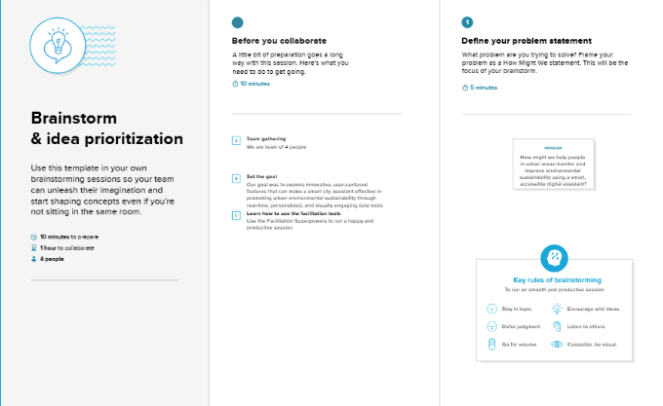

**Step-2: Brainstorm, Idea Listing and Grouping**

Once the problem is defined, the team moves into ideation. This is a divergent thinking phase where quantity is valued over quality — the aim is to generate as many ideas as possible, regardless of feasibility at this stage. Creativity, spontaneity, and free association are encouraged.

Ideas are typically documented using visual tools like sticky notes or digital whiteboards. After sufficient idea generation, the team begins to organize them into thematic clusters. Grouping helps in identifying patterns, redundancies, and categories that can inform later prioritization. This step ensures that related ideas are evaluated together, and it highlights emergent concepts.

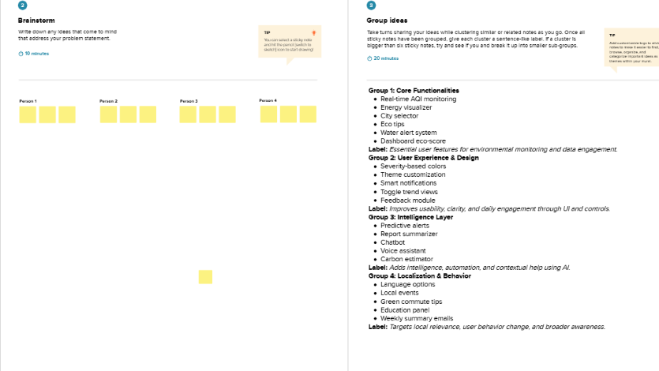

**Step-3: Idea Prioritization**

**After grouping, the team transitions into convergent thinking. This involves evaluating the ideas based on factors such as impact, feasibility, resource requirements, and alignment with project goals. A common tool used here is the Impact vs. Effort matrix, which helps categorize ideas into:**

* **Quick Wins (High impact, Low effort)**
* **Major Projects (High impact, High effort)**
* **Fill-ins (Low impact, Low effort)**
* **Time Wasters (Low impact, High effort)**

**This prioritization enables strategic decision-making, helping the team focus on ideas that deliver maximum value within available constraints. The final outcome is a clear, actionable set of prioritized ideas ready for implementation or further exploration.**

